****

**GUNNISON EXPORT RISERS FITNESS FOR SERVICE**

**WALL THICKNESS ASSESSMENT**

**NOVEMBER - 2018**

|  |  |  |  |  |  |
| --- | --- | --- | --- | --- | --- |
| **Document Revisions** | | | | | |
| **Rev.** | **Date** | **Description** | **Prepared By** | **Reviewed By** | **Approved By** |
| 01 | 20 Nov 2018 | New document | V. Achanta | V. Shah/  P. Enuganti | D. Gallagher |
|  |  |  |  |  |  |
|  |  |  |  |  |  |

***Prepared for:***

**Anadarko Petroleum Corporation**

**1201 Lake Robbins Drive**

**The Woodlands, Texas 77380**

***Prepared by:***

**Energo Engineering**

**601 Jefferson St.**

**Houston, Texas 77002**

**Energo Engineering Project No.: E18110**

**Energo Engineering Report No.: E18110-01**



***A Registered Texas Engineering Firm No: F-10973***

**REVISION TABLE**

|  |  |  |
| --- | --- | --- |
| **Rev** | **Date** | **Change Description** |
|  |  |  |

Table of Contents

[List of Figures iii](#_Toc530803332)

[List of Tables iv](#_Toc530803333)

[1 Summary 6](#_Toc530803334)

[2 Introduction 8](#_Toc530803335)

[3 Basis for FFS Assessment and Analysis Methodology 9](#_Toc530803336)

[3.1 Design Data 9](#_Toc530803337)

[3.2 Minimum Design Wall Thickness 10](#_Toc530803338)

[3.3 High Level Analysis Methodology 11](#_Toc530803339)

[3.4 Local Metal Loss – High Level Analysis Methodology 12](#_Toc530803340)

[4 Measured Data 14](#_Toc530803341)

[4.1 Oil Export Riser Piping 14](#_Toc530803342)

[4.1 Gas Export Riser Piping 19](#_Toc530803343)

[4.2 Measured Data Review 22](#_Toc530803344)

[5 FFS Assessment Results 24](#_Toc530803345)

[5.1 Oil Export Piping - Feature 3 24](#_Toc530803346)

[5.2 Oil Export Piping - Feature 4 26](#_Toc530803347)

[5.3 Gas Export Piping, Feature 3 30](#_Toc530803348)

[5.3.1 Flaw Size Sensitivity 34](#_Toc530803349)

[6 Conclusions and Recommendations 35](#_Toc530803350)

[7 REFERENCES 36](#_Toc530803351)

[Appendix A. Minimum Wall Thickness Requirements 37](#_Toc530803352)

[Appendix B. Local Metal Loss, Detailed Methodology and Calculations 38](#_Toc530803353)

[Appendix C. Comparison of PEC and UT Data 44](#_Toc530803354)

# List of Figures

[Figure 3.1 –Gunnison Export Riser Hull Piping 10](#_Toc530803355)

[Figure 3.2 –High Level FFS Analysis Methodology 12](#_Toc530803356)

[Figure 4.1 - Oil Export – Observed Features of Corrosion 15](#_Toc530803357)

[Figure 4.2 –Oil Export Riser Piping – Visuals 16](#_Toc530803358)

[Figure 4.3 - Oil Export, Feature 1 17](#_Toc530803359)

[Figure 4.4 - Oil Export, Feature 2 17](#_Toc530803360)

[Figure 4.5 - Oil Export, Feature 3 18](#_Toc530803361)

[Figure 4.6 - Oil Export, Feature 4 18](#_Toc530803362)

[Figure 4.7 - Gas Export – Observed Features of Corrosion 19](#_Toc530803363)

[Figure 4.8 –Gas Export Riser Piping – Visuals 20](#_Toc530803364)

[Figure 4.9 - Gas Export, Feature 1 21](#_Toc530803365)

[Figure 4.10 - Gas Export, Feature 2 21](#_Toc530803366)

[Figure 4.11 - Gas Export, Feature 3 22](#_Toc530803367)

[Figure 5.1 - Oil Export, Feature 3, Flaw Size: 6” X 6” (*Shown as Red Box*) 24](#_Toc530803368)

[Figure 5.2 – MAWP with FCA, Feature 3, FCAoutsideflaw = 1.00 \* FCAFlaw. 25](#_Toc530803369)

[Figure 5.3 - Oil Export, Feature 4, Flaw Size : 12” X 16” (*Shown as Red Box*) 26](#_Toc530803370)

[Figure 5.4 – MAWP with FCA, Feature 4, FCAoutsideflaw = 1.00 \* FCAFlaw. 28](#_Toc530803371)

[Figure 5.5 – MAWP with FCA, Feature 4, FCAoutsideflaw = 0.25 \* FCAFlaw 29](#_Toc530803372)

[Figure 5.6 - Gas Export, Feature 3, Flaw Size : 9” X 4” (*Shown as Red Box*) 30](#_Toc530803373)

[Figure 5.7 – MAWP with FCA, Feature 3, FCAoutsideflaw = 1.00 \* FCAFlaw 32](#_Toc530803374)

[Figure 5.8 – MAWP with FCA, Feature 3, FCAoutsideflaw = 0.25 \* FCAFlaw 33](#_Toc530803375)

[Figure 5.9 - Gas Export, Feature 3, Flaw Size : 5” X 4” (*Shown as Red Box*) as opposed to Flaw size (9 “ by 4”) shown by Red dotted lines 34](#_Toc530803376)

# List of Tables

[Table 1.1 – Timeline of Events 6](#_Toc530803377)

[Table 1.2 – Oil Export Riser, Current Rated Pressure & Future Corrosion Allowance 7](#_Toc530803378)

[Table 1.3 – Gas Export Riser, Current Rated Pressure & Future Corrosion Allowance 7](#_Toc530803379)

[Table 3.1: Design Data 9](#_Toc530803380)

[Table 3.2: Minimum Required Wall Thickness per Design Code Check 11](#_Toc530803381)

[Table 4.1 – Oil Export Piping - UT Wall Thickness Measurements 16](#_Toc530803382)

[Table 4.2 – Gas Export Piping - UT Wall Thickness Measurements 20](#_Toc530803383)

[Table 4.3 – Oil Export Riser, Measured Data Review 23](#_Toc530803384)

[Table 4.4 – Gas Export Riser, Measured Data Review 23](#_Toc530803385)

[Table 5.1 – Oil Export Riser, Feature 3, Current Rated Pressure & Future Corrosion Allowance 25](#_Toc530803386)

[Table 5.2 – Detailed Results, Feature 3, FCAoutsideflaw = 1.00 \* FCAFlaw. 26](#_Toc530803387)

[Table 5.3 – Oil Export Riser, Feature 4, Current Rated Pressure & Future Corrosion Allowance 27](#_Toc530803388)

[Table 5.4 – Detailed Results, Feature 4, FCAoutsideflaw = 1.00 \* FCAFlaw. 28](#_Toc530803389)

[Table 5.5 – Detailed Results, Feature 4, FCAoutsideflaw = 0.25 \* FCAFlaw. 29](#_Toc530803390)

[Table 5.6 – Gas Export Riser, Feature 3, Current Rated Pressure & Future Corrosion Allowance 31](#_Toc530803391)

[Table 5.7 – Detailed Results, Feature 3, FCAoutsideflaw = 1.00 \* FCAFlaw. 32](#_Toc530803392)

[Table 5.8 – Detailed Results, Feature 3, FCAoutsideflaw = 0.25 \* FCAFlaw. 33](#_Toc530803393)

[Table 5.9 – Gas Export Riser, Feature 3, Flaw Size Sensitivity 34](#_Toc530803394)

[Table 7.1: Minimum Required Wall Thickness Evaluation 37](#_Toc530803395)

###### **Abbreviations**

APC Anadarko Petroleum Corporation

FFS Fitness for service

FCA Future corrosion allowance, typically in inch

PEC Pulse Eddy Current

UT Ultrasound Thickness

WT Wall Thickness

Tnom

###### **Nomenclature**

Tnom Anadarko Petroleum Corporation

FCA

Tmm

# Summary

Wall thickness measurements are taken for Gunnison field Oil and Gas export riser hull piping below Spar deck. A brief timeline of the measurement events is given in Table 1.1.

|  |  |  |
| --- | --- | --- |
| **Date** | **Event** | **Description** |
| 24th, 25 Oct 2018 | Visual inspection | Visual inspection performed by CAN USA via ropes access. Scope of work is from SDV on Spar deck to water line.  Areas of corrosion on FBE section, coating disbondment, blistering reported at multiple locations below Spar deck. |
| 29th Oct 2018 | PEC on OE riser | Pulse Eddy Current (PEC) measurements on Oil Export riser. |
| 30th Oct 2018 | Pulsed Eddy Current on Gas Export riser | Pulse Eddy Current (PEC) measurements on Gas Export riser. |
| 4th, 5th Nov 2018 | Clean and UT Grid Readings on OE | Cleaning and grid UT (Ultrasonic Thickness) readings on Oil Export riser reported. |
| 6th Nov 2018 | Clean and UT Grid Readings on GE | Cleaning and grid UT readings on Gas Export riser reported |

Table . – Timeline of Events

Fitness for service assessment is conducted for oil and gas export riser pipings. Local metal loss, Level 2 assessment is conducted per API 579 fitness-for-service, Reference 2 and the results are summarized below:

* The PEC and UT data is reviewed and the UT data is utilized for further analysis.
* Based on API 579 Level 2 assessment and utilizing the current measured wall thickness profiles :
  + For the Oil Export riser piping, the maximum Allowable Working Pressure (MAWP) at the time of measurement is 2,850 psi which is higher than design MAOP of 2,220 psi, , Table 1.2
  + For the Gas Export riser piping, the maximum Allowable Working Pressure (MAWP) at the time of measurement is 2,678 psi which is higher than design MAOP of 2,220 psi, Table 1.3.
  + For both export riser pipings, the MAWP at the time of measurement is greater than the maximum allowable operating pressure (MAOP) of 2,220 psi and the pipings are acceptable for future operations.
* Based on API 579 Local Metal Loss Level 2 assessment:
  + The maximum allowable future corrosion allowance (FCA) is 0.127 inch for the Oil Export piping based on governing local thinning area of Feature 4, Table 1.2.
  + The maximum allowable future corrosion allowance (FCA) is 0.091 inch for the Gas Export piping based on governing local thinning area of Feature 3, Table 1.3.
  + The remaining life of the pipings can be established if the future corrosion rate is known. However the future corrosion rate is uncertain with the available data and therefore the remaining life is unknown.

The recommendations of the fitness for service study are as follows:

* Find root cause of corrosion and determine coating requirements as necessary.
* Reinstate coating immediately to arrest corrosion and obtain post-coating remediation visual feedback
* Based on coating quality, recommend 6 monthly UT grid readings for the following critical regions
  + Oil Export features 3 and 4;
  + Gas Export feature 3
* After corrosion rates are established and trended:
  + The remaining life of the piping can be established.
  + Inspection frequency may be increased to 12 months or greater based on condition based monitoring practices.

|  |  |  |
| --- | --- | --- |
| **Description** | **Current MAWP (psi)** | **FCA (in)** |
| Feature 4 (Local Thin Area of 12” x 16”)  Uniform Corr. Rate | 2850 | 0.127 |
| Feature 3 (Local Thin Area of 6” x 6”)  Uniform Corr. Rate | 3100 | 0.163 |
| Feature 4 (Local Thin Area of 12” x 16”)  Non-uniform Corr. Rate **(Use for Info Only)** | 2850 | 0.157 |

Table . – Oil Export Riser, Current Rated Pressure & Future Corrosion Allowance

|  |  |  |
| --- | --- | --- |
| **Assessment Area** | **Current MAWP (psi)** | **FCA (in)** |
| Feature 3 (Local Thin Area of 9” x 4”)  Uniform Corr. Rate | 2678 | 0.091 |
| Feature 3 (Local Thin Area of 9” x 4”)  Non-uniform Corr. Rate **(Use for Info Only)** | 2678 | 0.120 |

Table . – Gas Export Riser, Current Rated Pressure & Future Corrosion Allowance

# Introduction

Anadarko Petroleum Company operates the Gunnison field in Gulf of Mexico block GB 668 in water depth of 3150’. During a routine center well ropes access inspection, visible corrosion scale was observed on both the Oil and Gas export riser hull piping below Spar deck. Wall thickness at areas of observed corrosion has been measured by CAN-USA ropes access personnel through Pulse Eddy Current (PEC) and subsequently grid Ultrasonic Testing (UT).

Energo Engineering (Energo) has performed Engineering assessment based on measured wall thickness data to assess the Fitness for Service (FFS) of the riser piping for continued operations.

# Basis for FFS Assessment and Analysis Methodology

## Design Data

The design data for oil and gas export riser hull piping is given in Table 3.1 [5]. The elevation drawing for the piping below Spar deck is provided in Figure 3.1. The Spar deck elevation is 50’ above Mean Water Level (MWL). The bottom 33’ of piping below Spar deck until the top support has Splashtron coating and top 17’ of piping is coated with FBE.

|  |  |  |  |
| --- | --- | --- | --- |
| **Description** | **Units** | **Oil Riser Piping** | **Gas Riser Piping** |
| **Design Code** | n/a | ASME B31.4 | ASME B31.8 |
| **Outer Diameter, OD** | Inch | 18.0 | 16.0 |
| **Material Grade** | n/a | X-60 | X-65 |
| **Material Yield Strength, [1]** | Psi | 60,200 | 65,300 |
| **Maximum Allowable Operating Pressure, MAOP** | Psi | 2220 | 2220 |
| **Operating Pressures (psi)**  **(on 10-25-2018)** | Psi | 315 | 1245 |
| **Maximum Operating Temperature** | ˚F | 82 | 90 |
| **Ambient Temperature** | ˚F | 50 | 50 |
| **Nominal Wall Thickness, tnom** | Inch | 0.750 | 0.625 |
| **Operating Period (2004 to 2018)** | Years | 15 | 15 |

Table .: Design Data

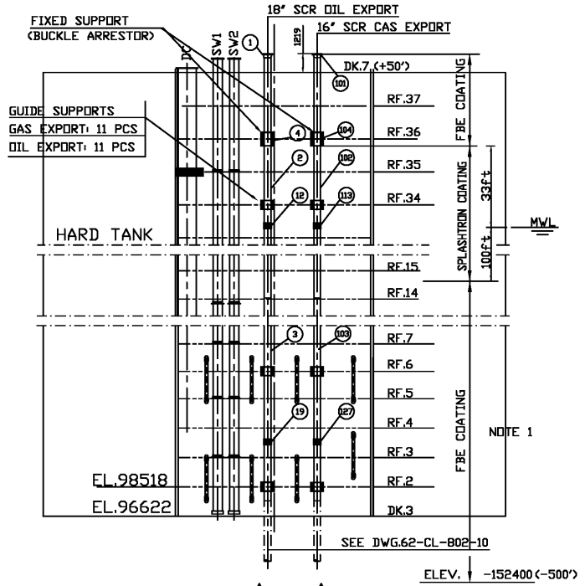

Figure . –Gunnison Export Riser Hull Piping

## Minimum Design Wall Thickness

The minimum wall thickness required is calculated using design data in Section 3.1 and corresponding design code.

* The minimum wall thickness required per design code at Maximum Allowable Operating Pressure (MAOP) is summarized below and listed in Table 3.2:
  + Oil export piping minimum required wall thickness is 0.538”.
  + Gas export piping minimum required wall thickness is 0.526”.
* The required minimum wall thickness per design check:
  + Is driven by internal pressure
  + This internal pressure check does not take into account the manufacturing tolerance, ovality etc.
  + A more detailed wall thickness sizing is provided in Appendix A.

|  |  |  |  |
| --- | --- | --- | --- |
| **Description** | **Units** | **Oil Riser Piping** | **Gas Riser Piping** |
| **Design Code** | n/a | ASME B31.4 | ASME B31.8 |
| **Governing Condition** | n/a | Internal Pressure | Internal Pressure |
| **Design Factor, Fd** | n/a | 0.60 | 0.50 |
| **Maximum Allowable Operating Pressure, MAOP** | psi | 2220 | 2220 |
| **Minimum Wall Thickness, tmin** | Inch | **0.538** | **0.526** |

Table .: Minimum Required Wall Thickness per Design Code Check

## High Level Analysis Methodology

To determine if the export riser piping is fit for service and to calculate Future Corrosion Allowance (FCA) at the locations of observed corrosion, two approaches were evaluated as per API 579-1/ ASME FFS-1 2016- General Metal Loss (GML) and Local Metal Loss (LML). GML is less conservative than LML, assumes smooth cross sections and uses an averaged thickness approach. Based on the UT results and wall thickness profiles along certain areas of circumference, LML was also analyzed. LML considers the area at and around the lowest measured wall thickness to determine a flaw profile. An allowable Future Corrosion Allowance (FCA) is calculated using LML.

The fitness-for-service analysis methodology used for the export riser piping assessment is described below:

* The piping can be considered as Type A.
* Screening of measured wall thickness profiles
* Following screening, it is determined that further assessment is required
* Typical assessments for metal loss are:
  + General metal loss (General corrosion, uniform corrosion)
  + Local metal loss (metal loss with wall thickness close to tmin or more in local areas, grooves etc.)
  + Pitting corrosion
* General metal loss is identified as follows:
  + Typically, if average wall thickness is closer to minimum wall than nominal wall, general metal loss analysis is required.
    - Ensure that there are no local stress concentrations or hot spots
    - Perform Level 1 analysis
    - If level 1 FCA (or remaining life) is unacceptable, adjust FCA or perform level 2
    - If level 2 FCA (or remaining life) is unacceptable, adjust FCA or perform level 3
    - Detailed methodology of general metal loss is given in Reference 2, Section 4.
* If local metal loss is identified:
  + Determine if it is local thin area (LTA) flaw or groove-like flaws
  + Perform Level 1 analysis as required.
  + If level 1 FCA (or remaining life) is unacceptable, adjust FCA or perform level 2
  + If level 2 FCA (or remaining life) is unacceptable, adjust FCA or perform level 3
* Acceptance criteria is as follows:
  + The remaining life is acceptable assuming an expected future corrosion rate(or)
  + The future corrosion allowance for remaining life is acceptable for the maximum allowable working pressure.
* A high level analysis methodology is shown in Figure 3.2.



Figure . –High Level FFS Analysis Methodology

## Local Metal Loss – High Level Analysis Methodology

The steps involved in the local metal loss analysis methodology is given in this section.

* Review measured thickness data to locate the region of metal loss
* Determine uniform thickness (trd) away from the local metal loss at the time of assessment
* Ensure the measurement intervals are sufficient to capture the thickness profile of the components
* Determine if the flaw area identified is categorized as
  + Groove (or)
  + Local thin area (LTA). This document addresses the local thin area (LTA) assessment going forward as only LTAs are identified for this project.
* Determine critical wall thickness (tc) to be used for assessment
* For the local thin area (LTA) or flaw region, determine the following
  + Minimum measured wall thickness, tmm
  + Flaw dimensions, s (length) and c(circumference)
* Determine remaining thickness ratio and longitudinal flaw length parameter to quantify the flaw intensity relative to the region outside the flaw.
  + Assume future corrosion allowance (FCA) at the flaw and away from the flaw
  + Utilize the FCA to help evaluate the future flaw shape and thickness of both the surface at and away from the flaw.
* Check to ensure that the LTA flaw dimensions are acceptable for assessment i.e. ensure that the LTA does fall under the groove criteria
* Determine MAWP of the component using the design code utilizing the measured wall thickness.
* Determine average wall thickness away from flaw (trd)
* Determine the remaining strength factor (RSF) due to the presence of the flaw
  + The RSF calculations takes into account more details progressing from level 1 assessment towards level 2 and/or level 3.
* Evaluate the Reduced MAWP based
  + MAWP evaluated using the design code
  + No derating of the component is performed if RSF is below the maximum allowable RSF of 0.9.
* Based on Level 1, if future corrosion allowance (FCA) assumed in evaluation above is unacceptable or marginal for the project, proceed to level 2 assessment.
  + Level 2 assessment is considered for this project

The above steps along with an example calculation along with all associated assumptions is given in Appendix B.

# Measured Data

The measured data for the Gunnison oil and gas export piping is described in this section. The following measured thickness data are obtained for the export risers:

* Initial Pulse Eddy Current (PEC) data, which has an accuracy of 20%, is used for screening purposes
* Ultrasonic Thickness (UT) data obtained by using the ultrasonic probe are accurate to within 0.001”. Local metal loss FFS assessment was performed based on UT data.

The UT wall thickness profile summary along with contour plots are shown below. A comparison between UT and PEC data is also shown in Appendix C for reference.

## Oil Export Riser Piping

The key features of the oil export riser obtained during visual inspection are shown in Figure 4.1 and Figure 4.2, [3]. The measured wall thickness data for the oil export riser is summarized in Table 4.1. The contour plots for the measured wall thickness areas are also given in this section.



Feature 4

Feature 3

Feature 2

Feature 1

Figure . - Oil Export – Observed Features of Corrosion

Figure . –Oil Export Riser Piping – Visuals

|  |  |  |  |  |  |
| --- | --- | --- | --- | --- | --- |
| **OE Feature ID#** | **Distance below Spar Deck** | **Contour Reference** | **Min WT Required** | **Min Measured WT** | **Avg WT Over all Measurements** |
| **#** |  |  | **Inch** | **Inch** | **Inch** |
| 1 | 1’ | Figure 4.3 | 0.538 | 0.668 | 0.736 |
| 2 | 3’ 6” | Figure 4.4 | 0.538 | 0.630 | 0.695 |
| 3 | 6’ 2” | Figure 4.5 | 0.538 | 0.580 | 0.687 |
| 4 | 9’ 6” | Figure 4.6 | 0.538 | 0.536 | 0.694 |

Table . – Oil Export Piping - UT Wall Thickness Measurements

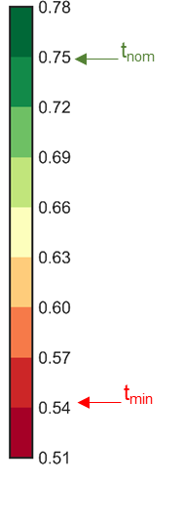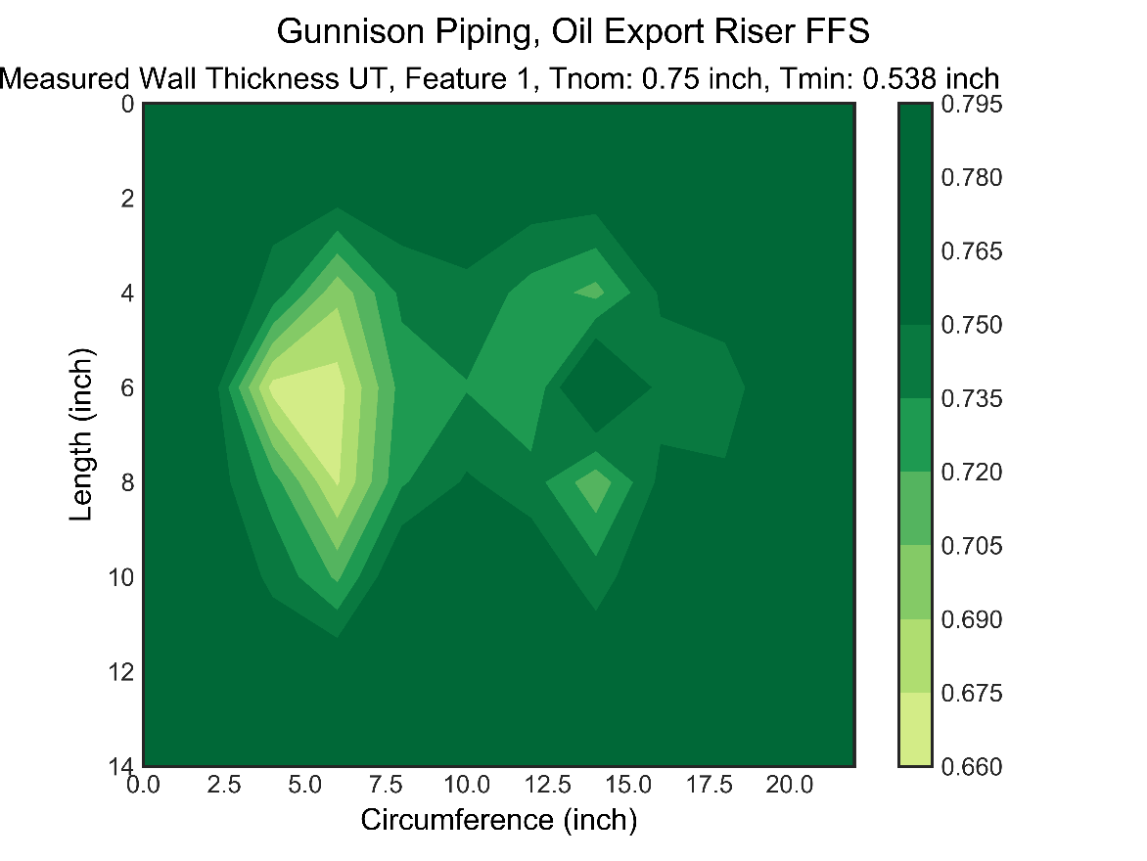

Figure . - Oil Export, Feature 1

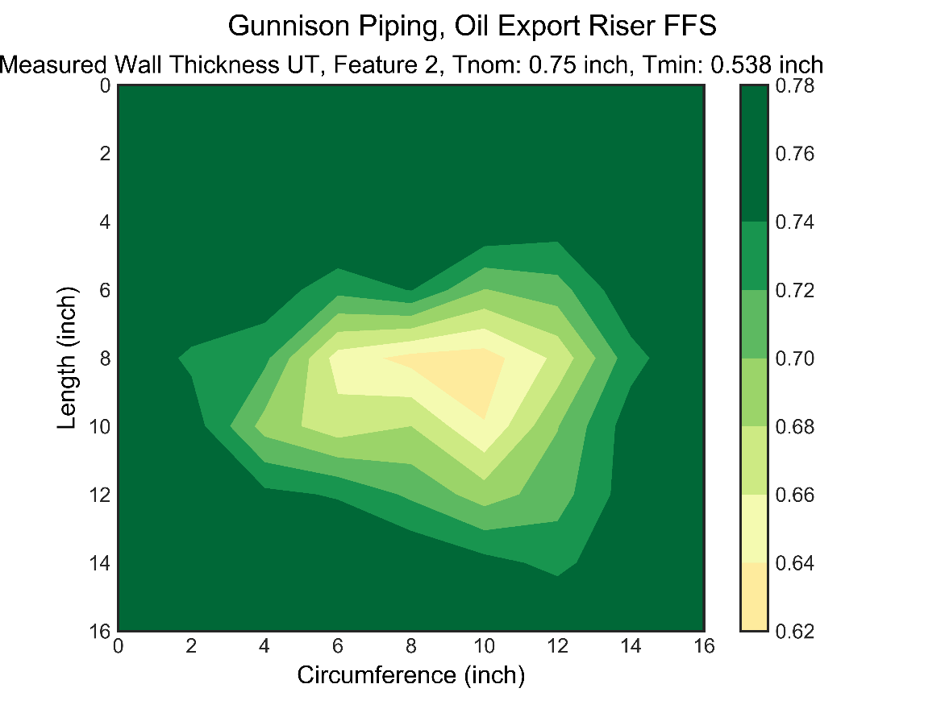

Figure . - Oil Export, Feature 2

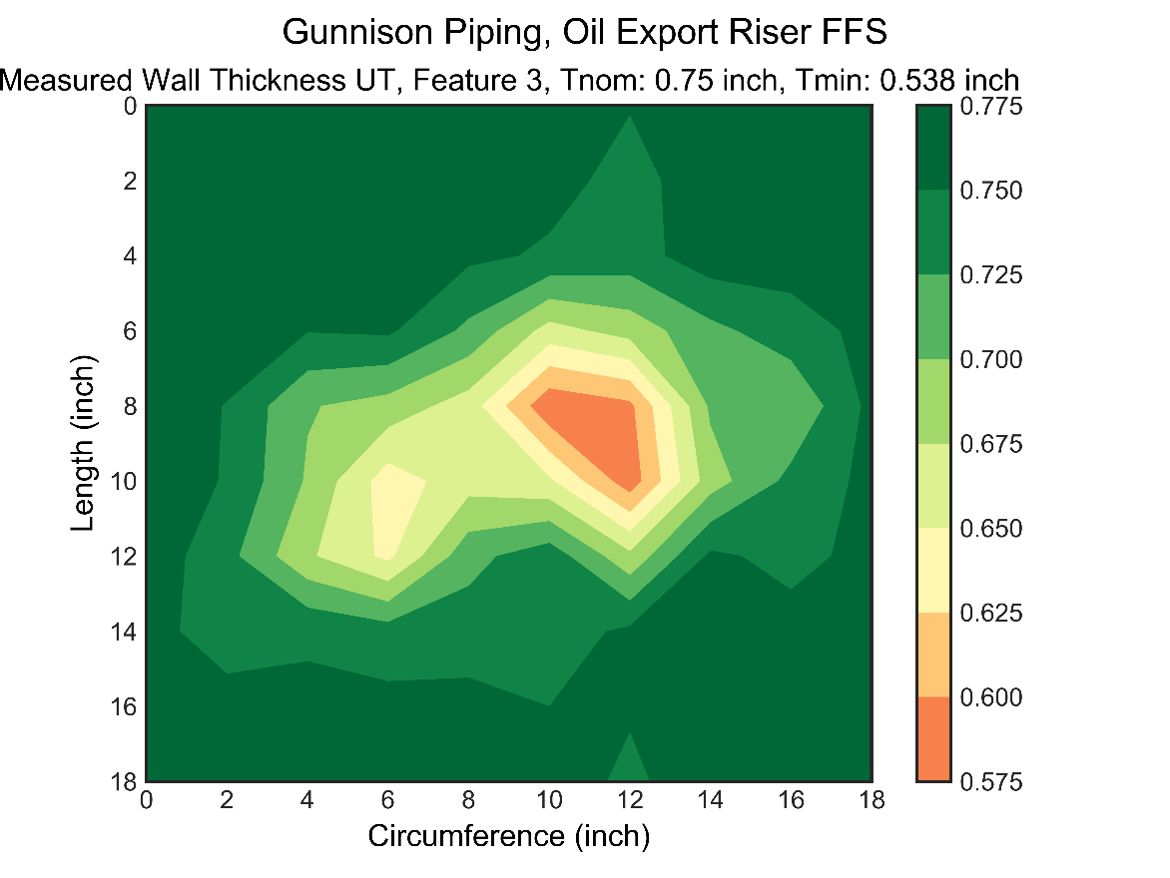

Figure . - Oil Export, Feature 3

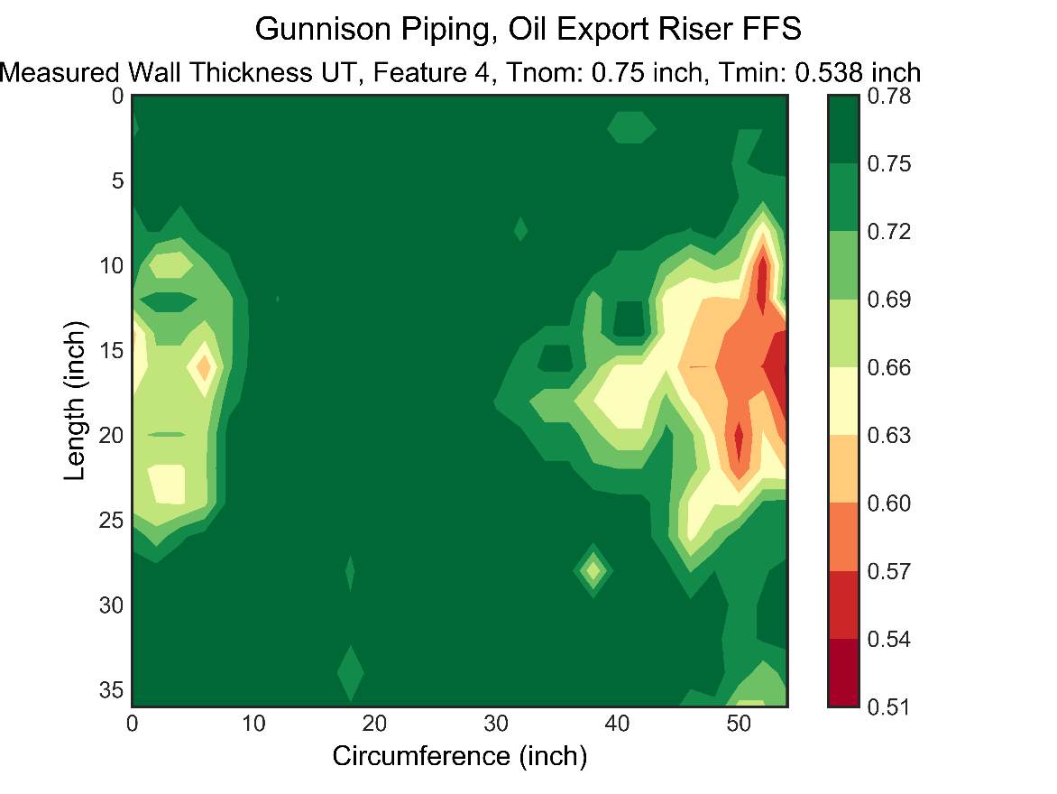

Figure . - Oil Export, Feature 4

## Gas Export Riser Piping

The key features of the gas export riser obtained during visual inspection are shown in Figure 4.7 and Figure 4.8. The measured wall thickness data for the gas export riser is summarized in Table 4.2. The contour plots for the measured wall thickness areas are also given in this section.

s

Feature 3

Feature 1

Feature 2

Figure . - Gas Export – Observed Features of Corrosion

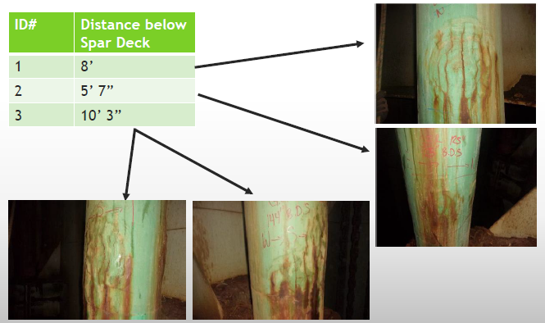

Figure . –Gas Export Riser Piping – Visuals

|  |  |  |  |  |  |
| --- | --- | --- | --- | --- | --- |
| **GE Feature ID** | **Distance below Spar Deck** | **Contour Reference** | **Min WT Required** | **Min Measured WT** | **Avg WT Over all Measurements** |
| **#** |  |  | **Inch** | **Inch** | **Inch** |
| 1 | 8’ | Figure 4.9 | 0.526 | 0.565 | 0.611 |
| 2 | 5’ 7” | Figure 4.10 | 0.526 | 0.560 | 0.623 |
| 3 | 10’ 3” | Figure 4.11 | 0.526 | 0.488 | 0.626 |

Table . – Gas Export Piping - UT Wall Thickness Measurements

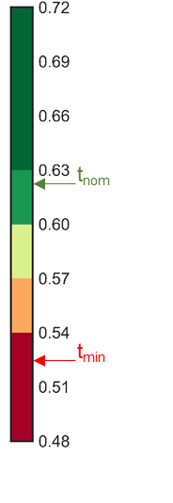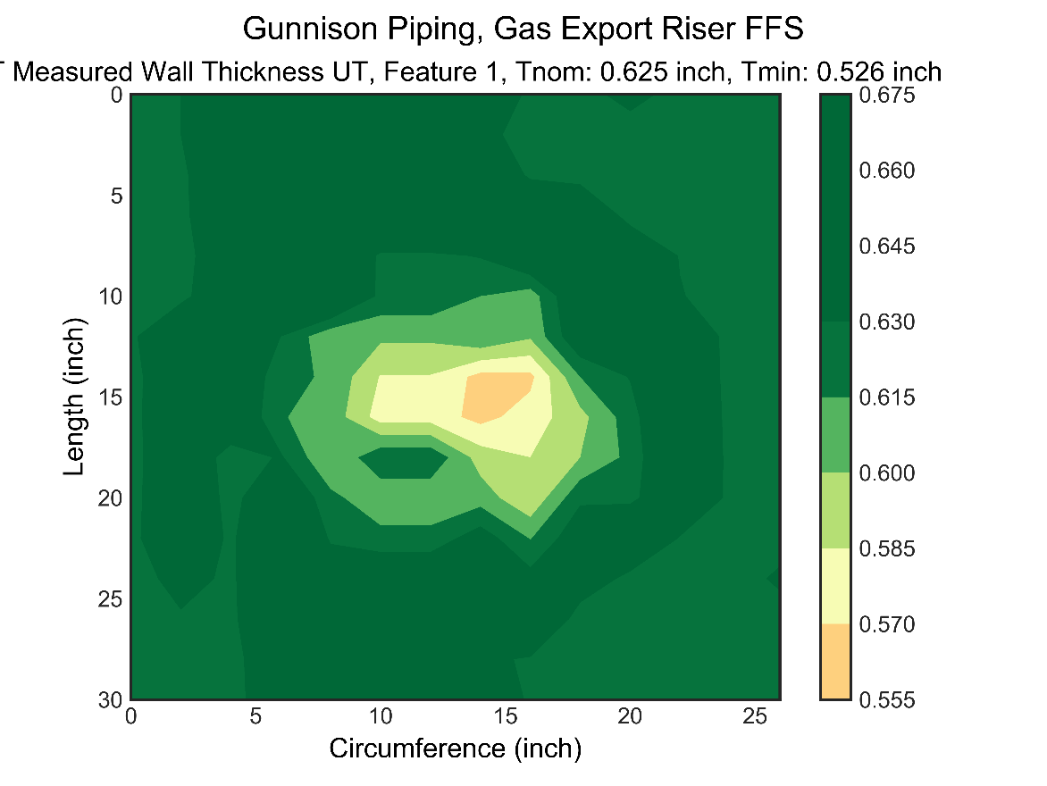

Figure . - Gas Export, Feature 1

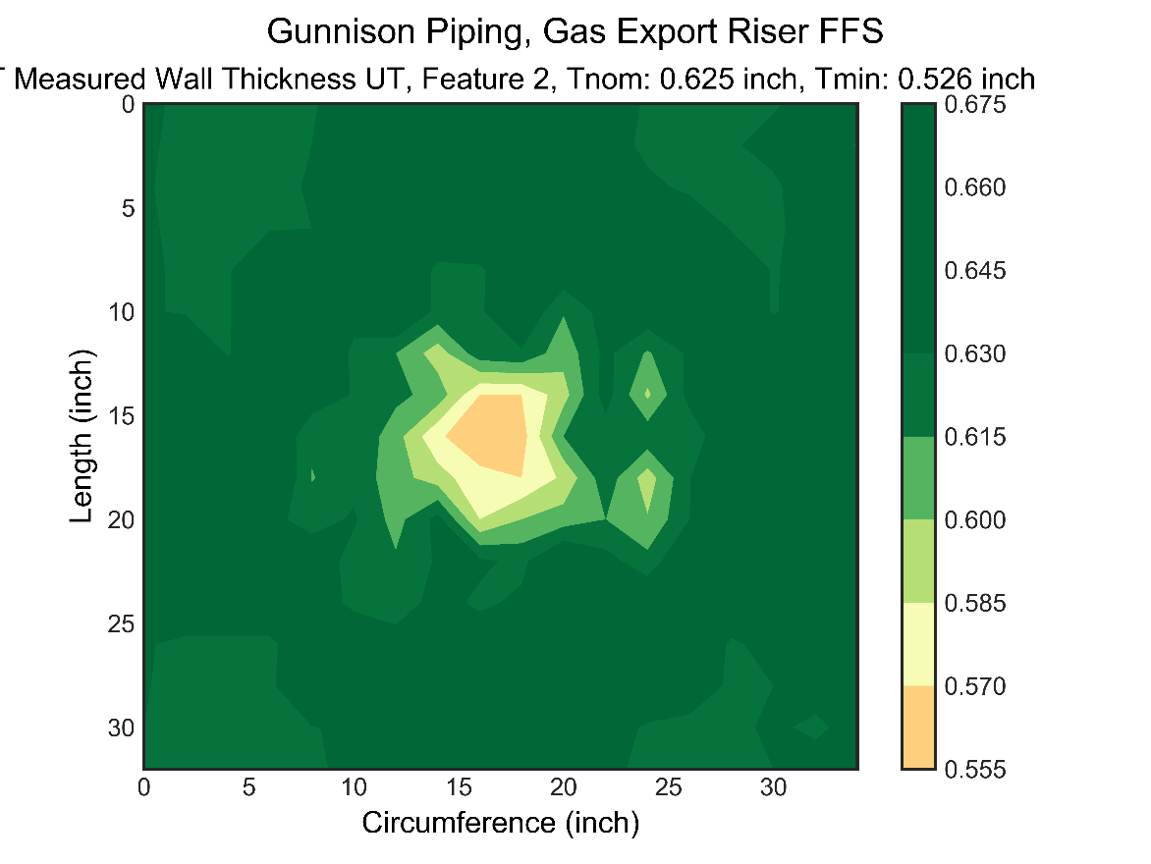

Figure . - Gas Export, Feature 2

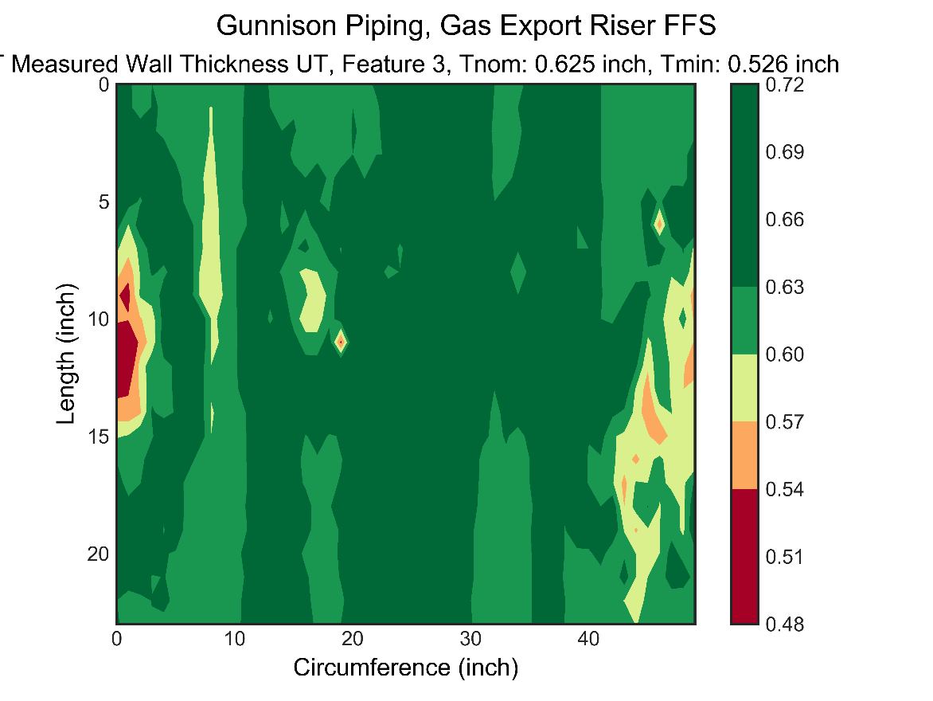

Figure . - Gas Export, Feature 3

## Measured Data Review

Measured data is reviewed to determine the fitness for service methodology to be used for analysis. Based on the review of the wall thickness measurements and contour plots in sections 4.1 and 4.1, the conclusions are as follows:

* General Metal Loss Review
  + Based on the thickness data review , the average measured wall thickness is found significantly higher than the minimum wall thickness (Tmin)
  + The general metal loss (GML) is purely based on average wall thickness in the length/area of measurement
  + An indicative GML remaining life percentage is estimated and given in Table 4.3 and Table 4.4 for oil and gas riser pipings respectively.
  + The remaining life for both pipings is greater than 50% and no further GML assessment is performed
* Local Metal Loss Review
  + Due to presence of measured wall thickness values close to the minimum wall, local metal loss assessment is required.
  + Local metal loss analysis is performed using the API 579 fitness for service code, Reference 2.
  + The features are selected for local metal loss analysis. The features selected for further assessment are based on the measured wall thickness (minimum and average) and in comparison with minimum required wall thickness.
  + Oil export riser piping, Table 4.3
    - Feature 3; Selected based on, minimum measured thickness is close to Tmin & average wall thickness is the lowest among all measurements.
    - Feature 4; Selected based on, minimum measured thickness is closest to Tmin.
  + Gas export riser piping, Table 4.4
    - Feature 3 based on multiple measurement data points below Tmin. Feature 3 is expected to be governing. Therefore, no other areas are considered for detailed assessment.

|  |  |  |  |  |  |  |
| --- | --- | --- | --- | --- | --- | --- |
| **Oil Export Feature ID** | **Min WT Required, Tmin** | **Tnom (inch)** | **Min Measured WT, tmm** | **Avg WT Over all Measurements, Tave** | **% GML Life Remaining, (Tave - Tmin)/ (Tnom - Tmin) \*100** | **Tmm/ Tmin** |
| **#** |  | **inch** | **inch** | **inch** | **#** | **#** |
| 1 | 0.538 | 0.75 | 0.668 | 0.736 | 93 | 1.24 |
| 2 | 0.538 | 0.75 | 0.63 | 0.695 | 74 | 1.17 |
| 3 | 0.538 | 0.75 | 0.58 | 0.687 | 70 | 1.08 |
| 4 | 0.538 | 0.75 | 0.536 | 0.694 | 74 | 1.00 |

Table . – Oil Export Riser, Measured Data Review

|  |  |  |  |  |  |  |
| --- | --- | --- | --- | --- | --- | --- |
| **Gas Export Feature ID** | **Min WT Required, Tmin** | **Tnom (inch)** | **Min Measured WT, tmm** | **Avg WT Over all Measurements, Tave** | **% GML Life Remaining, (Tave - Tmin)/ (Tnom - Tmin) \*100** | **Tmm/ Tmin** |
| **#** |  | **inch** | **inch** | **inch** | **#** | **#** |
| 1 | 0.526 | 0.625 | 0.565 | 0.611 | 86 | 1.07 |
| 2 | 0.526 | 0.625 | 0.56 | 0.623 | 98 | 1.06 |
| 3 | 0.526 | 0.625 | 0.488 | 0.626 | 101 | 0.93 |

Table . – Gas Export Riser, Measured Data Review

# FFS Assessment Results

Local Metal Loss (LML) Analysis is performed for the both the riser piping for the selected features, Section. 4.2. The LML analysis is to determine the future corrosion allowance for the continued future operations. The analysis is performed for oil and gas export risers for the following features:

* Oil export riser piping
  + Feature 3
  + Feature 4
* Gas export riser piping, Feature 3

The local metal loss analysis methodology used is given in Section 3.4 (and Appendix B).

## Oil Export Piping - Feature 3

The oil export riser piping, feature 3 local thin area is selected based on the minimum measured wall thickness in the feature. The selected local thin area (flaw size) selected is shown in Figure 5.1 for feature 3. The size of the local thin area flaw is 6 inch (length) by 6 inch (circumference).



Figure . - Oil Export, Feature 3, Flaw Size: 6” X 6” (*Shown as Red Box*)

Analysis is conducted using the measured data for Feature 3 and the results are given below:

* The flaw area used for the analysis is 6 inch by 6 inch
* The analysis is performed assuming uniform corrosion rate across the entire feature i.e. at and away from the flaw. The results are given in Table 5.1 and summarized below:
  + The Maximum Allowable Working Pressure (MAWP) at the time of measurement due to presence of flaw is 3100 psi.
  + This MAWP is greater than the maximum allowable operating pressure (MAOP) of 2,220 psi and the component is acceptable for future operations.
  + The maximum allowable FCA is 0.163” for MAOP of 2,220 psi based on level 2 assessment. The MAWP with varying future corrosion allowance is shown in Figure 5.2.
  + The maximum allowable FCA is 0.159” based on level 1 assessment and the level 1 methodology is considered conservative than level 2.
* The detailed local metal loss level 1 and level 2 assessment intermediate outputs and results are given in Table 5.2.

|  |  |  |  |  |
| --- | --- | --- | --- | --- |
| **Assessment Area** | **API 579 – Level 1** | | **API 579 – Level 2** | |
| **Current**  **MAWP (psi)** | **FCA (in)** | **Current**  **MAWP (psi)** | **FCA (in)** |
| Feature 3 (Local Thin Area of 6” x 6”)  Uniform Corr. Rate | 3100 | 0.159 | 3124 | 0.163 |

Table . – Oil Export Riser, Feature 3, Current Rated Pressure & Future Corrosion Allowance

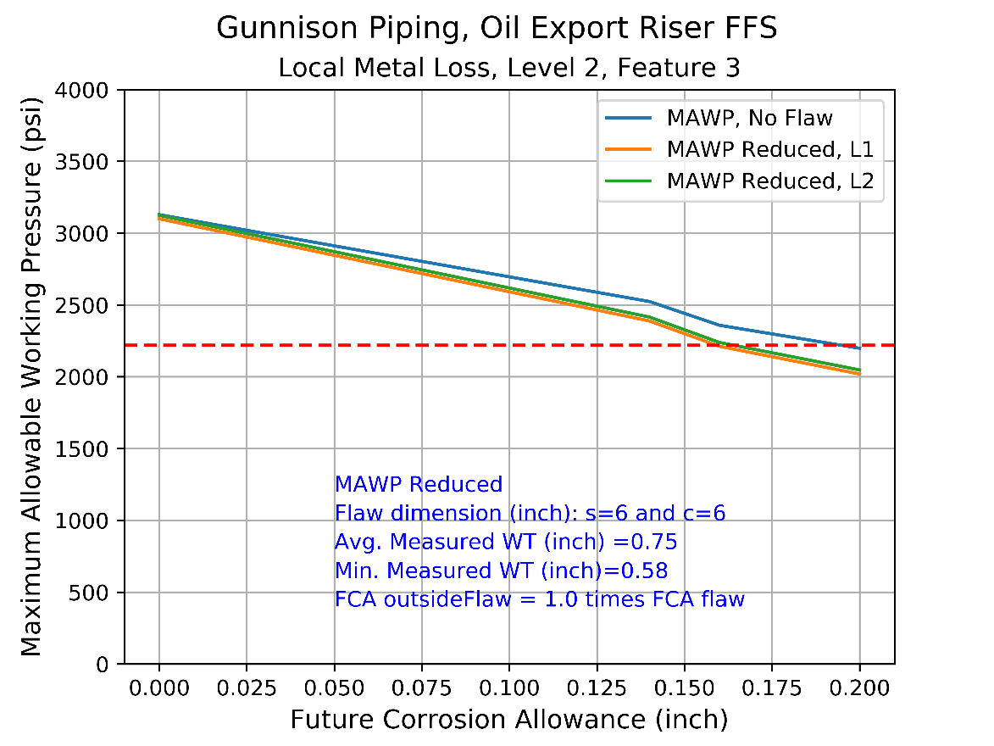

Figure . – MAWP with FCA, Feature 3, FCAoutsideflaw = 1.00 \* FCAFlaw.

|  |  |  |  |  |  |  |  |  |  |  |  |  |  |  |  |
| --- | --- | --- | --- | --- | --- | --- | --- | --- | --- | --- | --- | --- | --- | --- | --- |
| **FCA** | **Flaw Parameter** | **MAWP** | **MAWPr, L1** | **MAWPr, L2** | **MAWPrEval, L1** | **Mt, L1** | **Mt, L2** | **RSF, L1** | **RSF, L2** | **Rt** | **c** | **s** | **tavg** | **tc** | **tmm** |
| 0 | 2.92 | 3129 | 3100 | 3124 | TRUE | 1.71 | 1.379 | 0.892 | 0.899 | 0.774 | 6 | 6 | 0.75 | 0.75 | 0.58 |
| 0.02 | 2.96 | 3042 | 2998 | 3023 | TRUE | 1.724 | 1.387 | 0.887 | 0.894 | 0.768 | 6 | 6 | 0.75 | 0.73 | 0.58 |
| 0.04 | 3 | 2955 | 2897 | 2921 | TRUE | 1.739 | 1.395 | 0.882 | 0.89 | 0.761 | 6 | 6 | 0.75 | 0.71 | 0.58 |
| 0.06 | 3.05 | 2868 | 2795 | 2820 | TRUE | 1.755 | 1.405 | 0.877 | 0.885 | 0.754 | 6 | 6 | 0.75 | 0.69 | 0.58 |
| 0.08 | 3.09 | 2782 | 2693 | 2719 | TRUE | 1.771 | 1.415 | 0.871 | 0.88 | 0.747 | 6 | 6 | 0.75 | 0.67 | 0.58 |
| 0.1 | 3.14 | 2696 | 2592 | 2618 | TRUE | 1.788 | 1.425 | 0.865 | 0.874 | 0.739 | 6 | 6 | 0.75 | 0.65 | 0.58 |
| 0.12 | 3.19 | 2610 | 2490 | 2517 | TRUE | 1.805 | 1.436 | 0.859 | 0.868 | 0.731 | 6 | 6 | 0.75 | 0.63 | 0.58 |
| 0.14 | 3.24 | 2524 | 2388 | 2416 | TRUE | 1.824 | 1.448 | 0.852 | 0.861 | 0.722 | 6 | 6 | 0.75 | 0.61 | 0.58 |
| 0.16 | 3.3 | 2358 | 2212 | 2239 | TRUE | 1.844 | 1.46 | 0.844 | 0.854 | 0.712 | 6 | 6 | 0.75 | 0.59 | 0.58 |
| 0.18 | 3.35 | 2278 | 2116 | 2143 | TRUE | 1.864 | 1.473 | 0.836 | 0.847 | 0.702 | 6 | 6 | 0.75 | 0.57 | 0.58 |
| 0.2 | 3.41 | 2198 | 2019 | 2047 | TRUE | 1.887 | 1.487 | 0.827 | 0.838 | 0.691 | 6 | 6 | 0.75 | 0.55 | 0.58 |

Table . – Detailed Results, Feature 3, FCAoutsideflaw = 1.00 \* FCAFlaw.

## Oil Export Piping - Feature 4

The oil export riser piping, feature 4 local thin area is selected based on the minimum measured wall thickness in the feature. The selected local thin area (flaw size) selected is shown in Figure 5.3 for feature 3. The size of the local thin area flaw is 12 inch (length) by 16 inch (circumference).

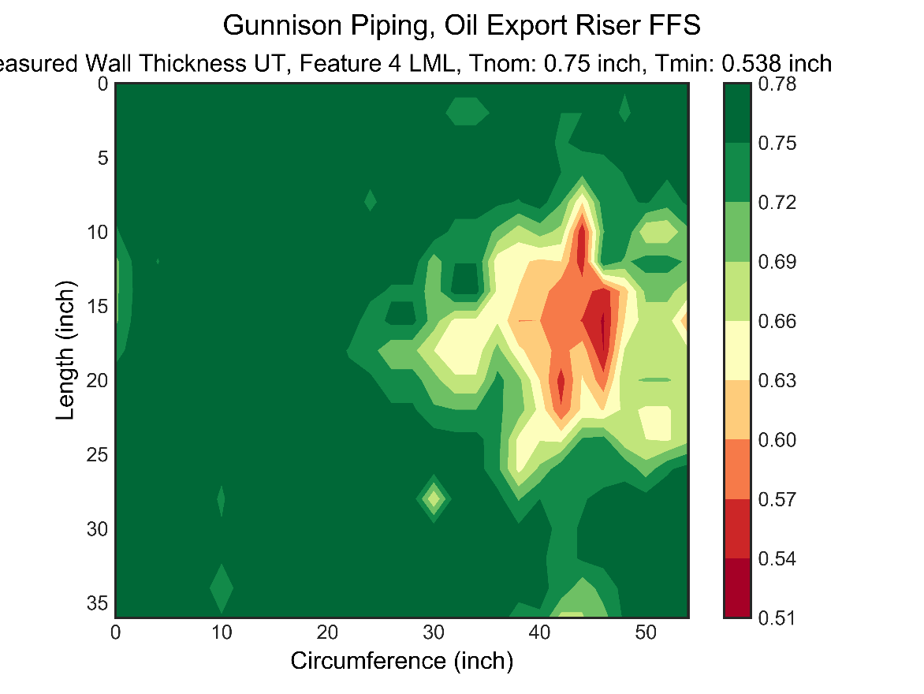

Figure . - Oil Export, Feature 4, Flaw Size : 12” X 16” (*Shown as Red Box*). Note: 0 inch Circumference start in this plot = 8 inch in measurement Report, Reference 3.

Analysis is conducted using the measured data for Feature 3 and the local metal loss analysis methodology given in Section 3.4 (and Appendix B) and the results are given below:

* The flaw area used for the analysis is 12 inch by 16 inch
* The analysis is performed for 2 different future corrosion rate assumptions and the results are given in Table 5.1 and described below.
* Uniform corrosion rate across the entire feature i.e. at and away from the flaw. The results are given below:
  + The Maximum Allowable Working Pressure (MAWP) at the time of measurement due to presence of flaw profile is 2,850 psi.
  + This MAWP is greater than the maximum allowable operating pressure (MAOP) of 2,220 psi and the component is acceptable for future operations.
  + The maximum allowable FCA is 0.127” for MAOP of 2,220 psi based on level 2 assessment. The MAWP with varying future corrosion allowance is shown in Figure 5.4.
  + The maximum allowable FCA is 0.100” based on level 1 assessment and the level 1 methodology is considered conservative than level 2.
  + The detailed local metal loss level 1 and level 2 assessment intermediate outputs and results are given in Table 5.4
* Non-uniform corrosion rate across the feature i.e. a higher corrosion rate the flaw. The results are given below:
  + Corrosion Rate away from flaw = 0.25 \* Corrosion Rate at the flaw
  + The maximum allowable FCA is 0.157” for MAOP of 2,220 psi based on level 2 assessment. The MAWP with varying future corrosion allowance is shown in Figure 5.5
  + The detailed local metal loss level 1 and level 2 assessment intermediate outputs and results are given in Table 5.5.

|  |  |  |  |  |
| --- | --- | --- | --- | --- |
| **Assessment Area** | **API 579 – Level 1** | | **API 579 – Level 2** | |
| **Current**  **MAWP (psi)** | **FCA (in)** | **Current**  **MAWP (psi)** | **FCA (in)** |
| Feature 4 (Local Thin Area of 12” x 16”)  Uniform Corr. Rate | 2766 | 0.108 | 2866 | 0.127 |
| **For Information Only** | | | | |
| Feature 4 (Local Thin Area of 12” x 16”)  Non-uniform Corr. Rate  **(Use for Info Only)** | 2766 | 0.126 | 2866 | 0.157 |

Table . – Oil Export Riser, Feature 4, Current Rated Pressure & Future Corrosion Allowance

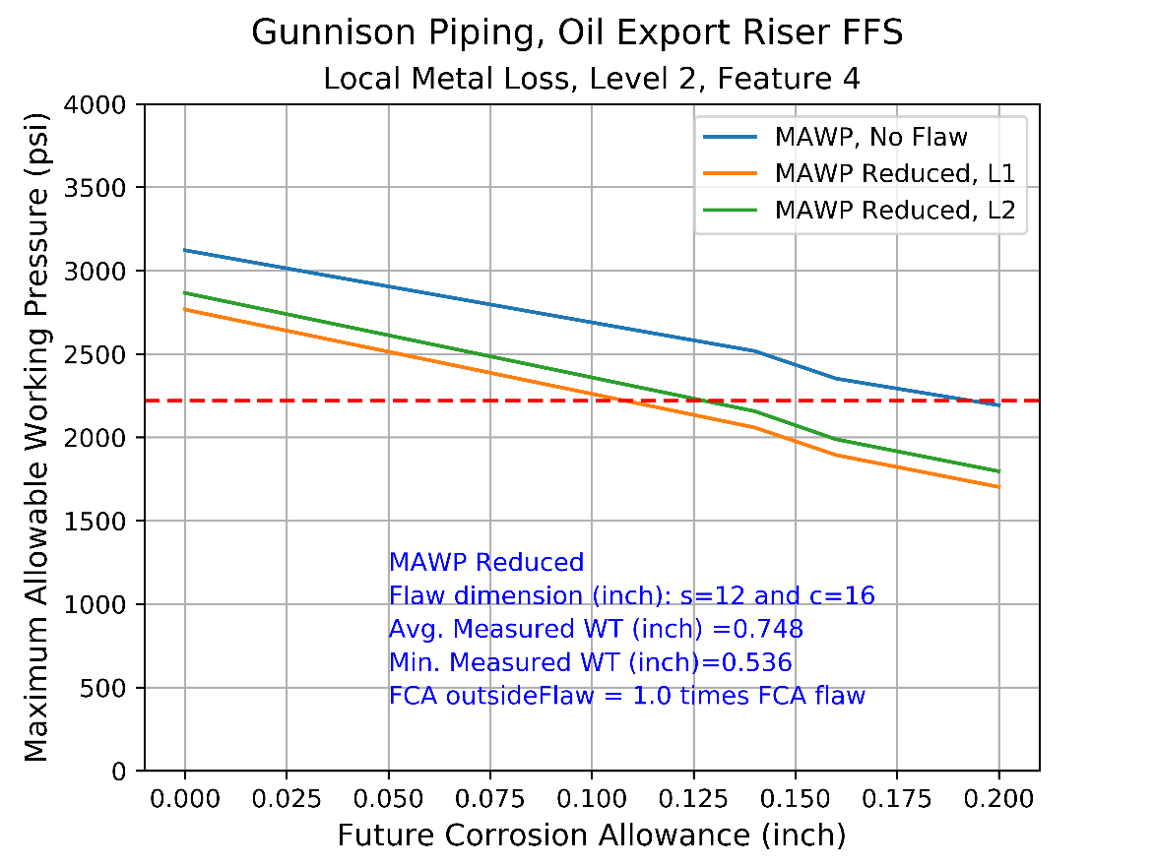

Figure . – MAWP with FCA, Feature 4, FCAoutsideflaw = 1.00 \* FCAFlaw.

|  |  |  |  |  |  |  |  |  |  |  |  |  |  |  |  |
| --- | --- | --- | --- | --- | --- | --- | --- | --- | --- | --- | --- | --- | --- | --- | --- |
| **FCA** | **Flaw Parameter** | **MAWP** | **MAWPr, L1** | **MAWPr, L2** | **MAWPrEval, L1** | **Mt, L1** | **Mt, L2** | **RSF, L1** | **RSF, L2** | **Rt** | **c** | **s** | **tavg** | **tc** | **tmm** |
| 0 | 5.12 | 3122 | 2766 | 2866 | TRUE | 2.792 | 1.38 | 0.797 | 0.826 | 0.716 | 16 | 12 | 0.748 | 0.748 | 0.536 |
| 0.02 | 5.19 | 3035 | 2665 | 2764 | TRUE | 2.822 | 1.387 | 0.79 | 0.82 | 0.709 | 16 | 12 | 0.748 | 0.728 | 0.536 |
| 0.04 | 5.26 | 2948 | 2564 | 2663 | TRUE | 2.852 | 1.396 | 0.783 | 0.813 | 0.7 | 16 | 12 | 0.748 | 0.708 | 0.536 |
| 0.06 | 5.34 | 2862 | 2463 | 2562 | TRUE | 2.884 | 1.405 | 0.775 | 0.806 | 0.692 | 16 | 12 | 0.748 | 0.688 | 0.536 |
| 0.08 | 5.42 | 2775 | 2362 | 2460 | TRUE | 2.917 | 1.416 | 0.766 | 0.798 | 0.683 | 16 | 12 | 0.748 | 0.668 | 0.536 |
| 0.1 | 5.5 | 2689 | 2261 | 2359 | TRUE | 2.952 | 1.426 | 0.757 | 0.789 | 0.673 | 16 | 12 | 0.748 | 0.648 | 0.536 |
| 0.12 | 5.59 | 2603 | 2160 | 2258 | TRUE | 2.988 | 1.437 | 0.747 | 0.781 | 0.662 | 16 | 12 | 0.748 | 0.628 | 0.536 |
| 0.14 | 5.68 | 2518 | 2059 | 2157 | TRUE | 3.027 | 1.449 | 0.736 | 0.771 | 0.651 | 16 | 12 | 0.748 | 0.608 | 0.536 |
| 0.16 | 5.78 | 2352 | 1894 | 1988 | TRUE | 3.067 | 1.461 | 0.725 | 0.761 | 0.639 | 16 | 12 | 0.748 | 0.588 | 0.536 |
| 0.18 | 5.88 | 2272 | 1798 | 1892 | TRUE | 3.108 | 1.474 | 0.712 | 0.749 | 0.627 | 16 | 12 | 0.748 | 0.568 | 0.536 |
| 0.2 | 5.98 | 2192 | 1702 | 1796 | TRUE | 3.152 | 1.488 | 0.699 | 0.737 | 0.613 | 16 | 12 | 0.748 | 0.548 | 0.536 |

Table . – Detailed Results, Feature 4, FCAoutsideflaw = 1.00 \* FCAFlaw.

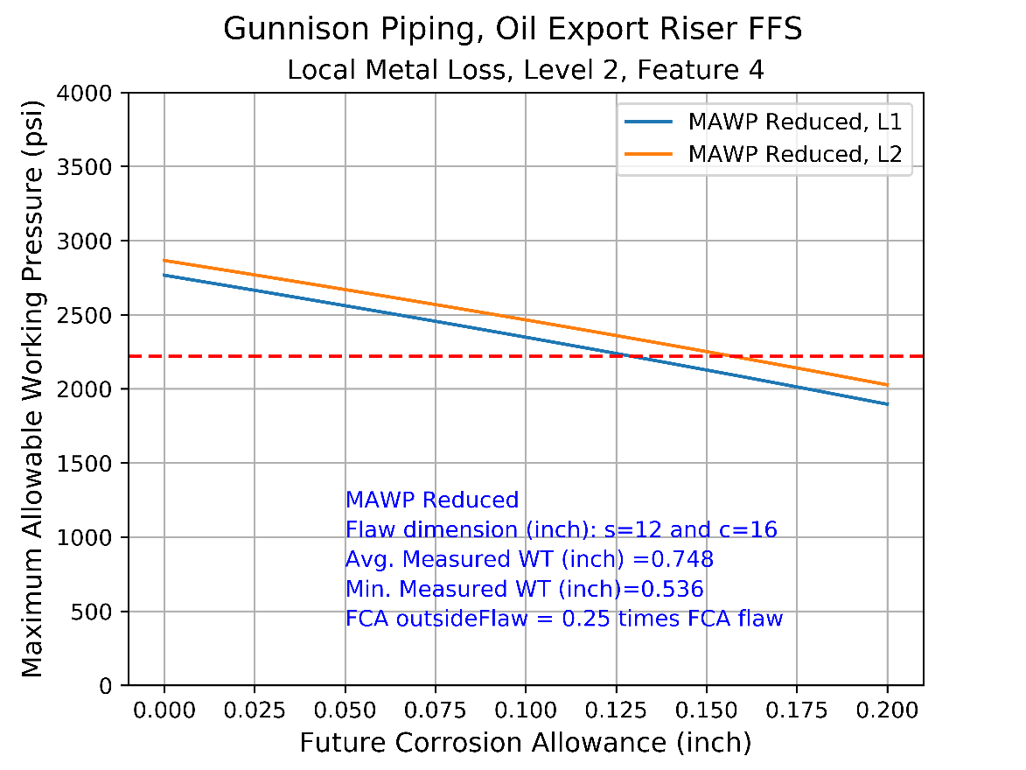

Figure . – MAWP with FCA, Feature 4, FCAoutsideflaw = 0.25 \* FCAFlaw

|  |  |  |  |  |  |  |  |  |  |  |  |  |  |  |  |
| --- | --- | --- | --- | --- | --- | --- | --- | --- | --- | --- | --- | --- | --- | --- | --- |
| **FCA** | **Flaw Parameter** | **MAWP** | **MAWPr, L1** | **MAWPr, L2** | **MAWPrEval, L1** | **Mt, L1** | **Mt, L2** | **RSF, L1** | **RSF, L2** | **Rt** | **c** | **s** | **tavg** | **tc** | **tmm** |
| 0 | 5.12 | 3122 | 2766 | 2866 | TRUE | 2.792 | 1.38 | 0.797 | 0.826 | 0.716 | 16 | 12 | 0.748 | 0.748 | 0.536 |
| 0.02 | 5.14 | 3100 | 2685 | 2788 | TRUE | 2.799 | 1.381 | 0.779 | 0.809 | 0.694 | 16 | 12 | 0.748 | 0.743 | 0.536 |
| 0.04 | 5.15 | 3079 | 2603 | 2710 | TRUE | 2.807 | 1.383 | 0.761 | 0.792 | 0.672 | 16 | 12 | 0.748 | 0.738 | 0.536 |
| 0.06 | 5.17 | 3057 | 2519 | 2630 | TRUE | 2.814 | 1.385 | 0.742 | 0.774 | 0.649 | 16 | 12 | 0.748 | 0.733 | 0.536 |
| 0.08 | 5.19 | 3035 | 2435 | 2548 | TRUE | 2.822 | 1.387 | 0.722 | 0.756 | 0.626 | 16 | 12 | 0.748 | 0.728 | 0.536 |
| 0.1 | 5.21 | 3014 | 2348 | 2465 | TRUE | 2.829 | 1.389 | 0.701 | 0.736 | 0.603 | 16 | 12 | 0.748 | 0.723 | 0.536 |
| 0.12 | 5.23 | 2992 | 2261 | 2381 | TRUE | 2.837 | 1.391 | 0.68 | 0.716 | 0.579 | 16 | 12 | 0.748 | 0.718 | 0.536 |
| 0.14 | 5.24 | 2970 | 2172 | 2295 | TRUE | 2.845 | 1.393 | 0.658 | 0.695 | 0.555 | 16 | 12 | 0.748 | 0.713 | 0.536 |
| 0.16 | 5.26 | 2948 | 2082 | 2208 | TRUE | 2.852 | 1.396 | 0.635 | 0.674 | 0.531 | 16 | 12 | 0.748 | 0.708 | 0.536 |
| 0.18 | 5.28 | 2927 | 1990 | 2118 | TRUE | 2.86 | 1.398 | 0.612 | 0.651 | 0.506 | 16 | 12 | 0.748 | 0.703 | 0.536 |
| 0.2 | 5.3 | 2905 | 1897 | 2027 | TRUE | 2.868 | 1.4 | 0.588 | 0.628 | 0.481 | 16 | 12 | 0.748 | 0.698 | 0.536 |

Table . – Detailed Results, Feature 4, FCAoutsideflaw = 0.25 \* FCAFlaw.

## Gas Export Piping, Feature 3

The gas export riser piping, feature 3 local thin area is selected based on the minimum measured wall thickness in the feature. The selected local thin area (flaw size) selected is shown in Figure 5.9 for feature 3. The size of the local thin area flaw is 9 inch (length) by 4 inch (circumference).

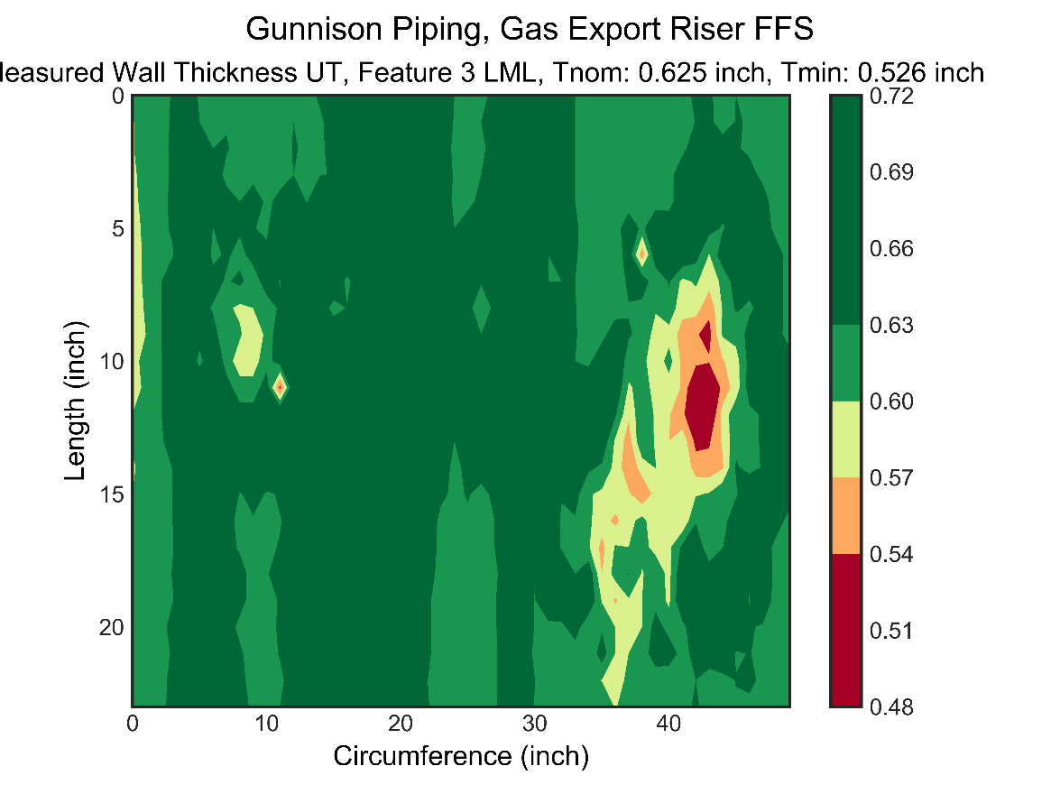

Figure . - Gas Export, Feature 3, Flaw Size : 9” X 4” (*Shown as Red Box*). Note: 0 inch Circumference start in this plot = 8 inch in measurement Report, Reference 4.

Analysis is conducted using the measured data for Feature 3 and the local metal loss analysis methodology given in Section, 3.4 (and Appendix B) and the results are given below:

* The flaw area used for the analysis is 9 inch by 4 inch
* The analysis is performed for 2 different future corrosion rate assumptions and the results are given in Table 5.6 and described below.
* Uniform corrosion rate across the entire feature i.e. at and away from the flaw. The results are given below:
  + The Maximum Allowable Working Pressure (MAWP) at the time of measurement due to presence of flaw profile is 2,678 psi.
  + This MAWP is greater than the maximum allowable operating pressure (MAOP) of 2,220 psi and the component is acceptable for future operations.
  + The maximum allowable FCA is 0.091” for MAOP of 2,220 psi based on level 2 assessment. The MAWP with varying future corrosion allowance is shown in Figure 5.7.
  + The maximum allowable FCA is 0.06” based on level 1 assessment and the level 1 methodology is considered conservative than level 2.
  + The detailed local metal loss level 1 and level 2 assessment intermediate outputs and results are given in Table 5.7.
* Non-uniform corrosion rate across the feature i.e. a higher corrosion rate the flaw. The results are given below:
  + Corrosion Rate away from flaw = 0.25 \* Corrosion Rate at the flaw
  + The maximum allowable FCA is 0.120” for MAOP of 2,220 psi based on level 2 assessment. The MAWP with varying future corrosion allowance is shown in Figure 5.8.
  + The detailed local metal loss level 1 and level 2 assessment intermediate outputs and results are given in Table 5.8.

|  |  |  |  |  |
| --- | --- | --- | --- | --- |
| **Assessment Area** | **API 579 – Level 1** | | **API 579 – Level 2** | |
| MAWP (psi) | FCA (in) | MAWP (psi) | FCA (in) |
| (Local Thin Area of 9” x 4”)  Uniform Corr. Rate | 2528 | 0.06 | 2678 | 0.091 |
| **For Information Only** | | | | |
| (Local Thin Area of 9” x 4”)  Non-uniform Corr. Rate  **(Use for Info Only)** | 2528 | 0.08 | 2678 | 0.120 |

Table . – Gas Export Riser, Feature 3, Current Rated Pressure & Future Corrosion Allowance

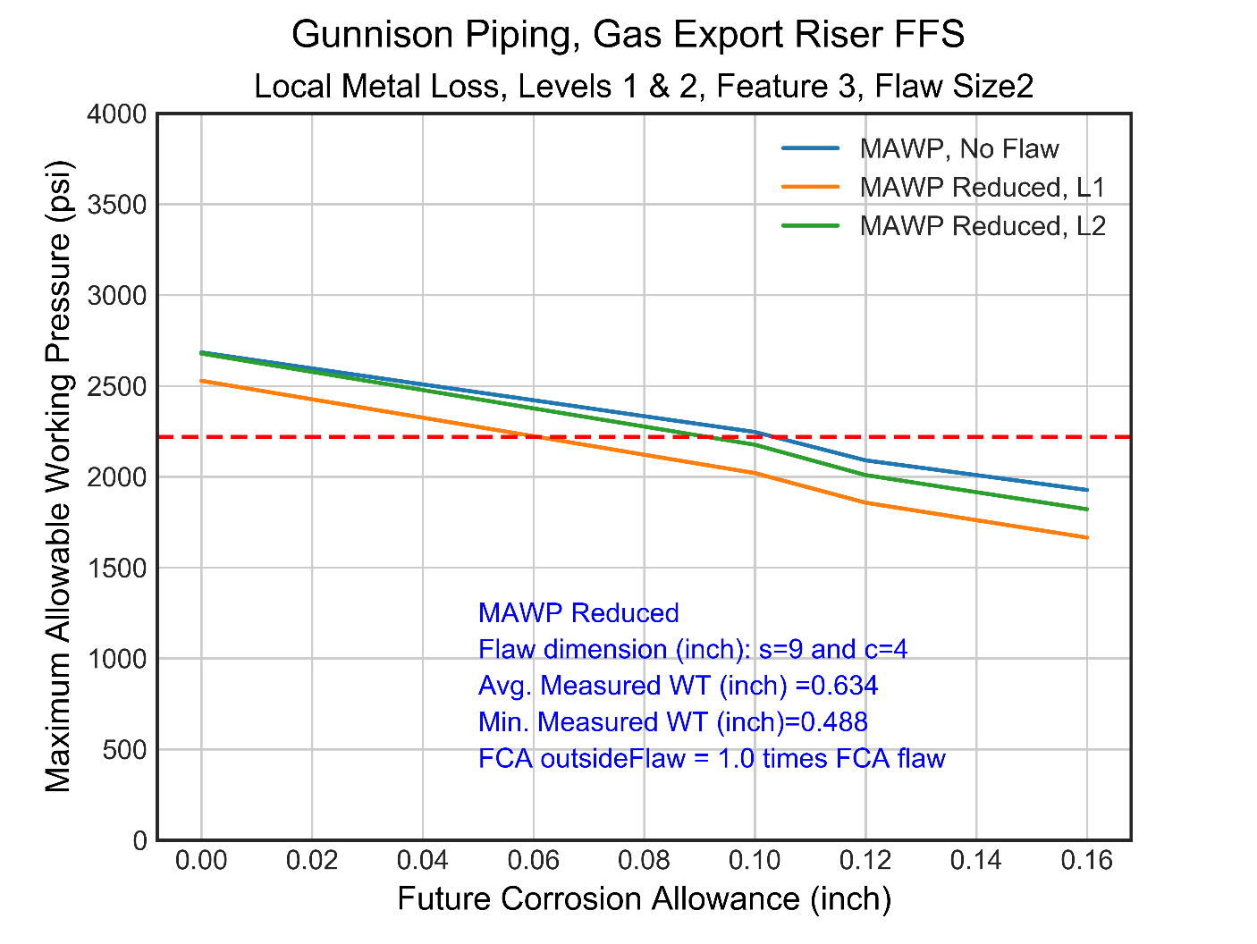

Figure . – MAWP with FCA, Feature 3, FCAoutsideflaw = 1.00 \* FCAFlaw

|  |  |  |  |  |  |  |  |  |  |  |  |  |  |  |  |
| --- | --- | --- | --- | --- | --- | --- | --- | --- | --- | --- | --- | --- | --- | --- | --- |
| **FCA** | **Flaw Parameter** | **MAWP** | **MAWPr, L1** | **MAWPr, L2** | **MAWPrEval, L1** | **Mt, L1** | **Mt, L2** | **RSF, L1** | **RSF, L2** | **Rt** | **c** | **s** | **tavg** | **tc** | **tmm** |
| 0 | 4.2 | 2684 | 2528 | 2678 | TRUE | 2.491 | 1.153 | 0.848 | 0.898 | 0.769 | 4 | 9 | 0.634 | 0.634 | 0.488 |
| 0.02 | 4.27 | 2596 | 2426 | 2577 | TRUE | 2.521 | 1.157 | 0.841 | 0.894 | 0.762 | 4 | 9 | 0.634 | 0.614 | 0.488 |
| 0.04 | 4.34 | 2508 | 2325 | 2477 | TRUE | 2.553 | 1.161 | 0.834 | 0.889 | 0.754 | 4 | 9 | 0.634 | 0.594 | 0.488 |
| 0.06 | 4.41 | 2421 | 2223 | 2376 | TRUE | 2.587 | 1.166 | 0.827 | 0.884 | 0.745 | 4 | 9 | 0.634 | 0.574 | 0.488 |
| 0.08 | 4.49 | 2333 | 2121 | 2276 | TRUE | 2.622 | 1.17 | 0.818 | 0.878 | 0.736 | 4 | 9 | 0.634 | 0.554 | 0.488 |
| 0.1 | 4.58 | 2246 | 2020 | 2176 | TRUE | 2.659 | 1.175 | 0.809 | 0.872 | 0.726 | 4 | 9 | 0.634 | 0.534 | 0.488 |
| 0.12 | 4.66 | 2090 | 1857 | 2009 | TRUE | 2.698 | 1.18 | 0.8 | 0.865 | 0.715 | 4 | 9 | 0.634 | 0.514 | 0.488 |
| 0.14 | 4.76 | 2009 | 1761 | 1915 | TRUE | 2.74 | 1.185 | 0.789 | 0.858 | 0.704 | 4 | 9 | 0.634 | 0.494 | 0.488 |
| 0.16 | 4.86 | 1927 | 1665 | 1821 | TRUE | 2.784 | 1.191 | 0.778 | 0.85 | 0.691 | 4 | 9 | 0.634 | 0.474 | 0.488 |
| 0.18 | 3.35 | 2278 | 2116 | 2143 | TRUE | 1.864 | 1.473 | 0.836 | 0.847 | 0.702 | 6 | 6 | 0.75 | 0.57 | 0.58 |
| 0.2 | 3.41 | 2198 | 2019 | 2047 | TRUE | 1.887 | 1.487 | 0.827 | 0.838 | 0.691 | 6 | 6 | 0.75 | 0.55 | 0.58 |

Table . – Detailed Results, Feature 3, FCAoutsideflaw = 1.00 \* FCAFlaw.

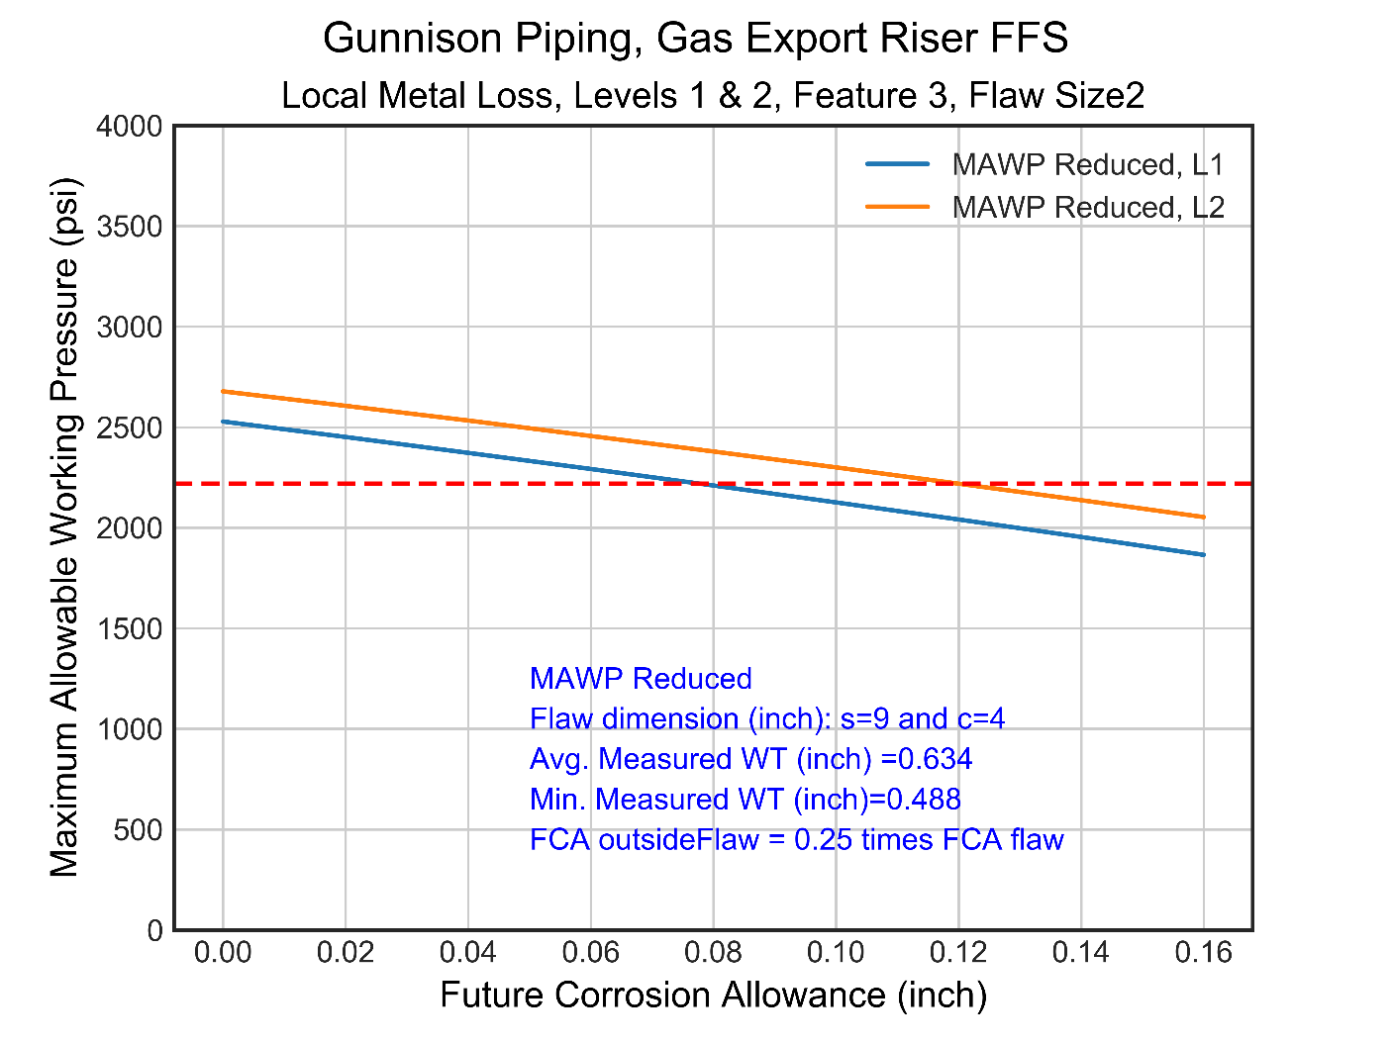

Figure . – MAWP with FCA, Feature 3, FCAoutsideflaw = 0.25 \* FCAFlaw

|  |  |  |  |  |  |  |  |  |  |  |  |  |  |  |  |
| --- | --- | --- | --- | --- | --- | --- | --- | --- | --- | --- | --- | --- | --- | --- | --- |
| **FCA** | **Flaw Parameter** | **MAWP** | **MAWPr, L1** | **MAWPr, L2** | **MAWPrEval, L1** | **Mt, L1** | **Mt, L2** | **RSF, L1** | **RSF, L2** | **Rt** | **c** | **s** | **tavg** | **tc** | **tmm** |
| 0 | 4.2 | 2684 | 2528 | 2678 | TRUE | 2.491 | 1.153 | 0.848 | 0.898 | 0.769 | 4 | 9 | 0.634 | 0.634 | 0.488 |
| 0.02 | 4.22 | 2662 | 2451 | 2606 | TRUE | 2.498 | 1.154 | 0.829 | 0.881 | 0.744 | 4 | 9 | 0.634 | 0.629 | 0.488 |
| 0.04 | 4.23 | 2640 | 2372 | 2533 | TRUE | 2.506 | 1.155 | 0.809 | 0.863 | 0.717 | 4 | 9 | 0.634 | 0.624 | 0.488 |
| 0.06 | 4.25 | 2618 | 2292 | 2456 | TRUE | 2.513 | 1.156 | 0.788 | 0.845 | 0.691 | 4 | 9 | 0.634 | 0.619 | 0.488 |
| 0.08 | 4.27 | 2596 | 2210 | 2379 | TRUE | 2.521 | 1.157 | 0.766 | 0.825 | 0.664 | 4 | 9 | 0.634 | 0.614 | 0.488 |
| 0.1 | 4.29 | 2574 | 2126 | 2300 | TRUE | 2.529 | 1.158 | 0.743 | 0.804 | 0.637 | 4 | 9 | 0.634 | 0.609 | 0.488 |
| 0.12 | 4.3 | 2552 | 2041 | 2219 | TRUE | 2.537 | 1.159 | 0.72 | 0.783 | 0.609 | 4 | 9 | 0.634 | 0.604 | 0.488 |
| 0.14 | 4.32 | 2530 | 1954 | 2137 | TRUE | 2.545 | 1.16 | 0.695 | 0.76 | 0.581 | 4 | 9 | 0.634 | 0.599 | 0.488 |
| 0.16 | 4.34 | 2508 | 1865 | 2053 | TRUE | 2.553 | 1.161 | 0.669 | 0.737 | 0.552 | 4 | 9 | 0.634 | 0.594 | 0.488 |
| 0.18 | 3.35 | 2278 | 2116 | 2143 | TRUE | 1.864 | 1.473 | 0.836 | 0.847 | 0.702 | 6 | 6 | 0.75 | 0.57 | 0.58 |
| 0.2 | 3.41 | 2198 | 2019 | 2047 | TRUE | 1.887 | 1.487 | 0.827 | 0.838 | 0.691 | 6 | 6 | 0.75 | 0.55 | 0.58 |

Table . – Detailed Results, Feature 3, FCAoutsideflaw = 0.25 \* FCAFlaw.

### Flaw Size Sensitivity

The size of the local thin area flaw for Feature 2 is reduced from 9 inch (length) by 4 inch (circumference) to 5 inch (length) by 4 inch (circumference) to assess the sensitivity of the results based on chosen flaw size. The size of the local thin area flaw is shown in Figure 5.9 and the results are given in Table 5.9 and summarized below:

* Reducing the flaw size increases the maximum future corrosion allowable by 4% from 0.091 inches to 0.095 inches based on local metal loss level 2 assessment.
* The FCA increases by 33% from 0.06 inch to 0.08 inch based on local metal loss level 1 assessment.
* 

Figure . - Gas Export, Feature 3, Flaw Size : 5” X 4” (*Shown as Red Box*) as opposed to Flaw size (9 “ by 4”) shown by Red dotted lines. Note: 0 inch Circumference start in this plot = 8 inch in measurement Report, Reference 4.

|  |  |  |  |  |
| --- | --- | --- | --- | --- |
| **Assessment Area** | **API 579 – Level 1** | | **API 579 – Level 2** | |
| MAWP (psi) | FCA (in) | MAWP (psi) | FCA (in) |
| Flaw Size (Local Thin Area of 9” x 4”)  Uniform Corr. Rate | 2528 | 0.06 | 2678 | 0.091 |
| Flaw Size (Local Thin Area of 5” x 4”)  Uniform Corr. Rate | 2660 | 0.08 | 2680 | 0.095 |

Table . – Gas Export Riser, Feature 3, Flaw Size Sensitivity

# Conclusions and Recommendations

Fitness for service analysis is conducted for the oil and gas riser pipings and the conclusions are given below:

* Based on API 579 Level 2 assessment utilizing the current measured wall thickness profiles :
  + For the Oil Export riser piping, the maximum Allowable Working Pressure (MAWP) at the time of measurement is 2,850 psi which is higher than design MAOP of 2,220 psi
  + For the Gas Export riser piping, the maximum Allowable Working Pressure (MAWP) at the time of measurement is 2,678 psi which is higher than design MAOP of 2,220 psi
  + For both export riser pipings, the MAWP at the time of measurement is greater than the maximum allowable operating pressure (MAOP) of 2,220 psi and the pipings are acceptable for future operations.
* Based on API 579 Local Metal Loss Level 2 assessment:
  + The maximum allowable future corrosion allowance (FCA) is 0.127 inch for the Oil Export piping based on governing local thinning area of Feature 4.
  + The maximum allowable future corrosion allowance (FCA) is 0.091 inch for the Gas Export piping based on governing local thinning area of Feature 3.
  + The remaining life of the pipings can be established if the future corrosion rate is known. However the future corrosion rate is uncertain with the available data and therefore the remaining life is unknown.

The recommendations of the fitness for service study are as follows:

* Reinstate coating immediately to arrest corrosion and obtain post-coating remediation visual feedback
* Based on coating quality, recommend 6 monthly UT grid readings for the following critical regions
  + Oil Export features 3 and 4;
  + Gas Export feature 3
* After corrosion rates are established and trended, inspection frequency may be increased to 12 months or greater based on condition based monitoring practices.

# REFERENCES

1. American Petroleum Institute, “Specification for Line Pipe”, API SPEC 5L, October 2007
2. American Petroleum Institute, “Fitness-For-Service”, API 579-1/ASME FFS-1, June 2016
3. CAN, “UT (UTT) Examination of Oil Export Riser, Gunnison Area Center Well”, 5 November 2018
4. CAN, “UT (UTT) Examination of Gas Export Riser, Gunnison Area Center Well”, 7 November 2018
5. Kerr McGee Oil and Gas Corporation, “Gunnison Project – Piping Lay-out, Export Risers Hard Tank”, 62-CL-802-01, Rev AB, 16 January 2002.
6. Minimum Wall Thickness Requirements

The minimum wall thickness required based on design code is evaluated for the following:

* Hoop stress driven by Internal pressure
* Equivalent stress driven by all stress components

The minimum wall thickness required and the design code parameters used for the evaluation are given in Table 7.1.

|  |  |  |  |
| --- | --- | --- | --- |
| **Description** | **Units** | **Oil Riser Piping** | **Gas Riser Piping** |
| **Design Code** | n/a | ASME B31.4 | ASME B31.8 |
| **Temperature Derating** | n/a | None | None |
| **Internal Pressure (Governing Condition)** | | | |
| **Design Factor, Fd** | n/a | 0.60 | 0.50 |
| **Maximum Allowable Operating Pressure, MAOP** | psi | 2220 | 2220 |
| **Minimum Wall Thickness, tmin** | Inch | **0.538** | **0.526** |
| **All Loads – Equivalent Stress** | | | |
| **Design Factor, Fd** | n/a | 0.90 | 0.90 |
| **Maximum Allowable Operating Pressure, MAOP** | psi | 2220 | 2220 |
| **Maximum Operating Temperature** | ˚F | 82 | 90 |
| **Ambient Temperature** | ˚F | 50 | 50 |
| **Minimum Wall Thickness, tmin** | Inch | **0.417** | **0.337** |

Table .: Minimum Required Wall Thickness Evaluation

1. Local Metal Loss, Detailed Methodology and Calculations

A detailed calculation for local metal loss is provided in this section. The detailed calculation is for:

* Gas export riser
* Feature 3, Flaw Size of
* FCAoutsideflaw = 0.25 \* FCAFlaw.
* Example calculations provided below are for FCAFlaw of

|  |  |  |
| --- | --- | --- |
| **Calculation** | **Value** | **Comments, Reference 2** |
| **For Level 1 Assessment** |  |  |
|  |  | Get Wall thickness readings.  API 579,  LML Level 1, Reference 2, Section 5.4.2 |
|  | trd = 0.634 inch | Get uniform thickness away from local metal loss  API 579,  GML Level 1, Reference 2, Section .4.2 |
|  | Check | Defines the measurement interval  API 579,  LML Level 1, Reference 2, Section 5.4.2 |
|  | LTA, No grooves | Determine if local thin area or groove type of local flaw  API 579,  LML Level 1, Reference 2, Section 5.4.2 |
|  | FCA = 0.025 inch  FCAml=0.100 inch  tc = 0.609 inch | API 579,  LML Level 1, Reference 2, Section 5.4.2 |
|  | Tmm = 0.488 inch  s = 9 inch  c = 4 inch | API 579,  LML Level 1, Reference 2, Section 5.4.2 |
|  | FCAml=0.100 inch  Tnom = 0.625  Rt = 0.637  Lambda = 4.286 | API 579,  LML Level 1, Reference 2, Section 5.4.2 |
|  | True  True | API 579,  LML Level 1, Reference 2, Section 5.4.2 |
|  | Not required | API 579,  LML Level 1, Reference 2, Section 5.4.2 |
|  |  | API 579,  LML Level 1, Reference 2, Section 5.4.2 |
|  | RSF = 0.743  RSFa = 0.90  Current rated pressure, MAWP = 2574 psi | API 579,  LML Level 1, Reference 2, Section 5.4.2 |
| Evaluate MAWPR | MAWPR = RSF/RSFa \* MAWP = (0.743/0.9)\*2574= 2124 |  |
| **For Level 2** |  |  |
| As Future Corrosion Allowance obtained utilizing level 1 are considered marginal by the project, level 2 assessment is also performed to increase the Future Corrosion Allowance margins. |  |  |
| Perform calcualtions until Step 7 from Level 1 above. |  | API 579,  LML Level 2, Reference 2, Section 5.4.2 |
| Replaced (Ai/Ao) in RSFi formula above with 1- (Ai/Ao) to obtain meaningful reasults. | Minimum RSF for all measured wall thickness value and flaw size combination arranged in ascending order = 0.804 | API 579,  LML Level 2, Reference 2, Section 5.4.2 |
|  | MAWPR = RSF/RSFa \* MAWP = (0.804/0.9)\*2574= 2300 |  |

1. Comparison of PEC and UT Data

The following measured thickness data are given in this section:

* Pulse Eddy Current (PEC) data obtained by using the pulse eddy current tool
* Ultrasonic Thickness (UT) data obtained by using the ultrasonic gauge/

The UT measurements are known to be more accurate than PEC measurements.

**Oil Export, UT vs. PEC**

|  |  |
| --- | --- |
| **UT Data** | **PEC Data** |
| C:\Users\vamsee.achanta\Dropbox\Engineering\0176 KBR FFS Analysis\COD\API579\results\Plots\Ut grid area 4 oil export_UT, Feature 1_Contour.png | C:\Users\vamsee.achanta\Dropbox\Engineering\0176 KBR FFS Analysis\COD\API579\results\Plots\PEC Oil Export_PEC, Feature 1_Contour.png |
| C:\Users\vamsee.achanta\Dropbox\Engineering\0176 KBR FFS Analysis\COD\API579\results\Plots\Ut grid area 3 oil export_UT, Feature 2_Contour.png | C:\Users\vamsee.achanta\Dropbox\Engineering\0176 KBR FFS Analysis\COD\API579\results\Plots\PEC Oil Export_PEC, Feature 2_Contour.png |
| C:\Users\vamsee.achanta\Dropbox\Engineering\0176 KBR FFS Analysis\COD\API579\results\Plots\Ut grid area 2 oil export_UT, Feature 3_Contour.png | C:\Users\vamsee.achanta\Dropbox\Engineering\0176 KBR FFS Analysis\COD\API579\results\Plots\PEC Oil Export_PEC, Feature 3_Contour.png |
| C:\Users\vamsee.achanta\Dropbox\Engineering\0176 KBR FFS Analysis\COD\API579\results\Plots\Ut grid area 1 oil export_UT, Feature 4_Contour.png | C:\Users\vamsee.achanta\Dropbox\Engineering\0176 KBR FFS Analysis\COD\API579\results\Plots\PEC Oil Export_PEC, Feature 4_Contour.png |

**Gas Export, UT vs. PEC**

|  |  |
| --- | --- |
| **UT Data** | **PEC Data** |
| C:\Users\vamsee.achanta\Dropbox\Engineering\0176 KBR FFS Analysis\COD\API579\results\Plots\Gas export area 1 grid_UT_UT, Feature 1_Contour.png | C:\Users\vamsee.achanta\Dropbox\Engineering\0176 KBR FFS Analysis\COD\API579\results\Plots\PEC Gas Export Below Spar_PEC, Feature 1_Contour.png |
| C:\Users\vamsee.achanta\Dropbox\Engineering\0176 KBR FFS Analysis\COD\API579\results\Plots\Gas export area 2 grid_UT_UT, Feature 2_Contour.png | C:\Users\vamsee.achanta\Dropbox\Engineering\0176 KBR FFS Analysis\COD\API579\results\Plots\PEC Gas Export Below Spar_PEC, Feature 2_Contour.png |
| C:\Users\vamsee.achanta\Dropbox\Engineering\0176 KBR FFS Analysis\COD\API579\results\Plots\gas export area 3 grid_UT_UT, Feature 3_Contour.png | C:\Users\vamsee.achanta\Dropbox\Engineering\0176 KBR FFS Analysis\COD\API579\results\Plots\PEC Gas Export Below Spar_PEC, Feature 3_Contour.png |